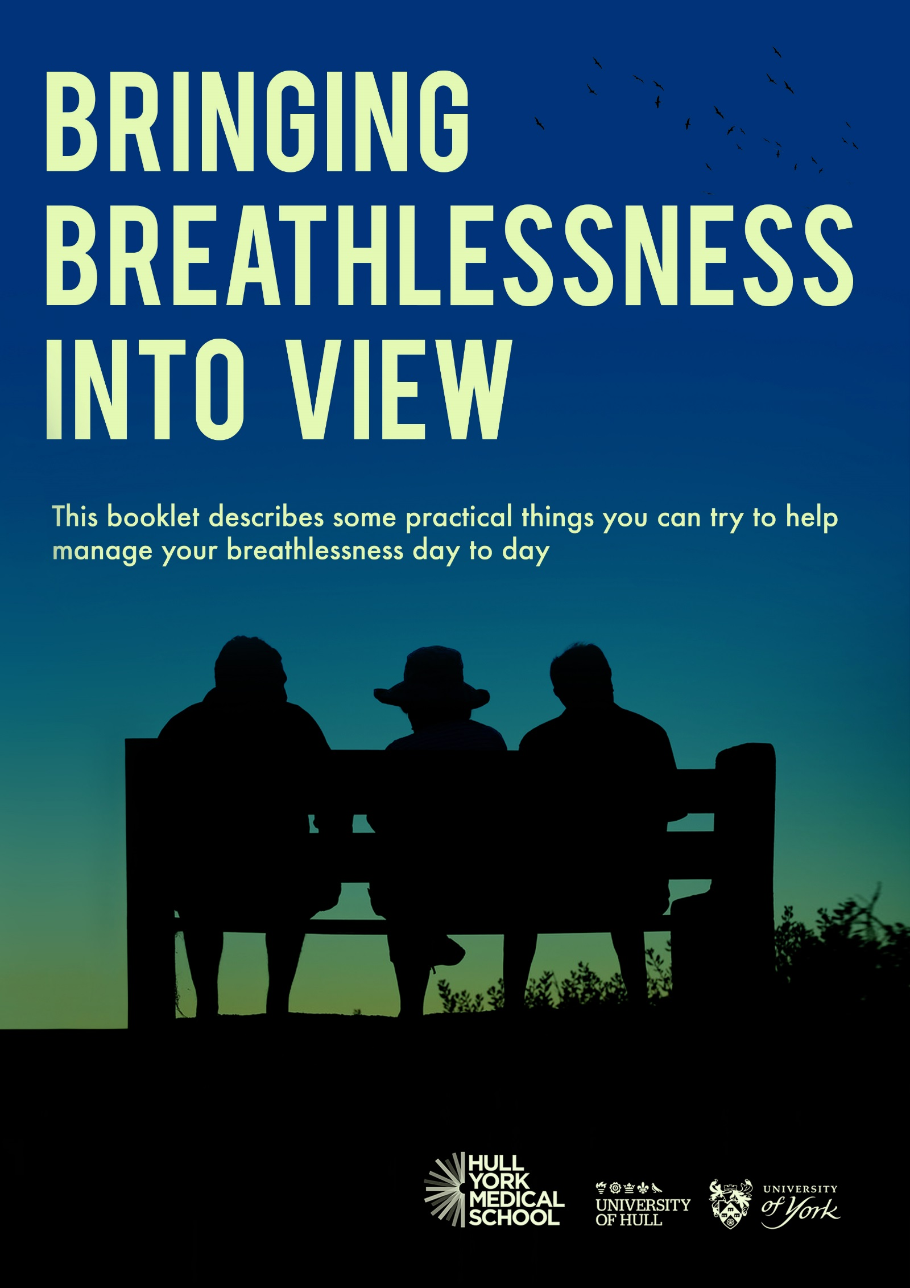

Introduction
This booklet describes some practical things you can try to help manage your breathlessness day to day. Also, there is a section on where to get support and information.

using The handheld fan

Breathlessness can be reduced by a draught of cool air from a handheld fan directed at the face. Keep the fan with you at all times so that you have it ready in times of need. You can use the fan whenever you feel breathless. You may find it helpful to use the fan with other breathlessness management techniques such as positioning, breathing control, relaxation and mindfulness.
Using the handheld fan

- Hold the fan about 6 inches (15cm) from your face or the distance you find most helpful.

- Aim the cool air at your cheeks, nose and mouth.

- Either hold the fan still or move it around slightly, whatever you find most helpful.
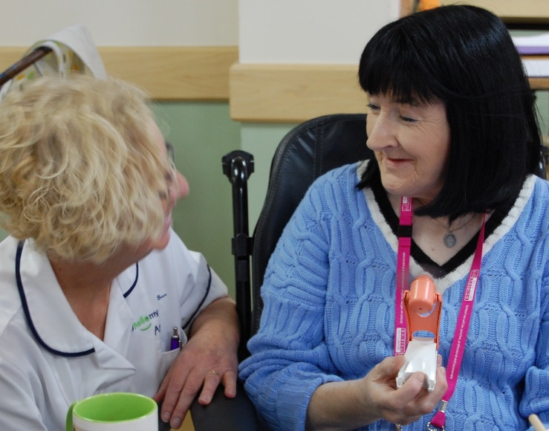

Breathing exercises

In this section there are several suggestions of ways to ease breathlessness that you may find helpful. Try each one and if you find it isn’t helpful then leave it and try another one.

Breathe low and slow, relax, let go
If you have a tendency to breathe with small, fast breaths from the top of your chest you may find taking slower, deeper breaths from your tummy helps to ease breathlessness.
Relaxed tummy breathing
The relaxed tummy breathing method can help reduce effort of breathing and speed up recovery. This type of exercise will give you a feeling of breathing around the waist.

Preparation
- Find a comfortable sitting position with your back and arms well supported (leaning forward may help)
- Relax your shoulders down and keep your upper chest as still as possible
- Place one hand on your tummy, just above your belly button

Spend as long as you need on each of the following points:
- Feel the breathing movement under your hand
- Breathe in slowly and smoothly, allow your tummy to swell
- Breathe out through the mouth, let your tummy fall and try to let go of any tension in your body
- Each time you breathe out, let go a little more.

Breathing from your tummy in this way often does not come naturally. You should therefore practice breathing control when you are not breathless for 10-15 minutes at a time, at least twice a day. This will help you master the technique. Breathe gently when practising; there should only be a slight movement of your tummy at rest.

Breathe a rectangle
When practising relaxed tummy breathing some people like to imagine a rectangle. Wherever you are, there is often a rectangle to be seen,
whether this is a book, a TV, computer or tablet screen, a door, window, table top or even a picture on the wall. Follow the sides of the rectangle with your eyes as you tummy breathe. Gradually slow the speed of which your eyes move around the edge of the shape to slow your breathing. This is to help you time more time over your breathe-out than your breathe-in which is important to get the best from each breathe-in.

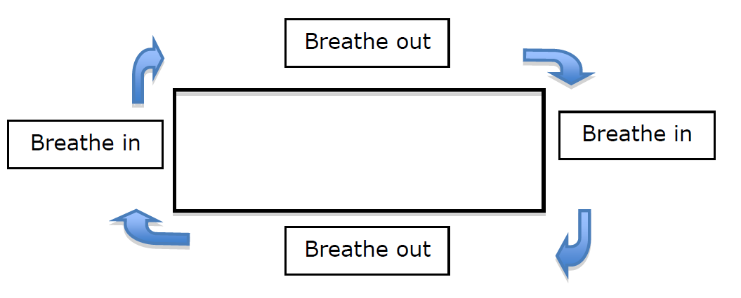

Pursed lips breathing

Some people find breathing in through the nose and out through narrowed lips helps to ease their breathlessness. This technique tends to help people who have conditions such as chronic obstructive pulmonary disease (COPD) or emphysema. People who find this technique helpful often use it already without realising they are doing it.
Pursed lips breathing helps to keep the airways open thereby allowing the air to leave the lungs more easily. This creates more room for the next breath in. You can use pursed lips breathing at the same time as relaxed tummy breathing and with the hand-held fan.

Positions to ease breathlessness

Forward lean position
The following positions may help you to recover from breathlessness. With all positions, try to relax the hands, wrists, shoulders, neck and jaw as much as possible. There is no one position which suits everyone, nor one position which people with a particular condition prefer. Experiment with different positions and find what works best for you. The handheld fan can be used with these positions.
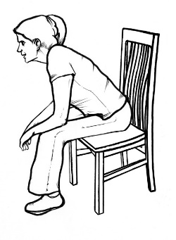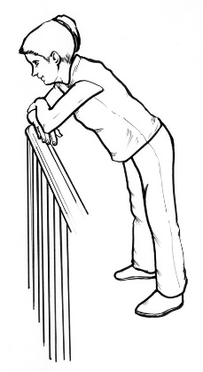
Resting positions
The following positions may help if you are breathless at rest or if you are feeling very tired or exhausted.

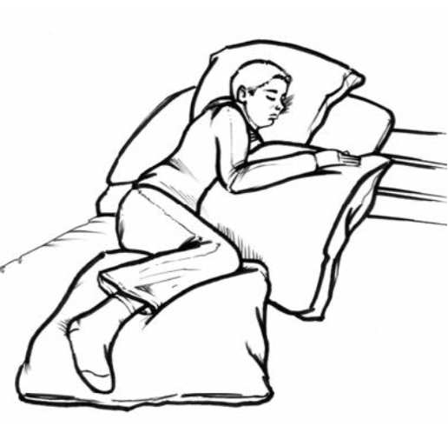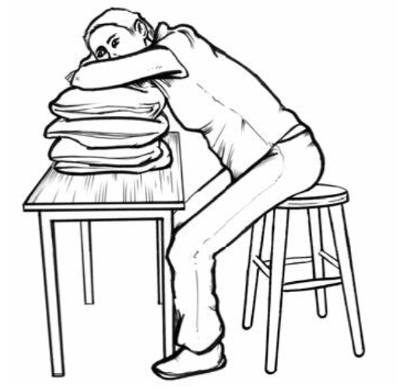
Relax down onto the pillows as much as possible. Having your legs apart may also help.
Make sure you are fully over on your side. Resting your upper arm on a pillow may also help.
Managing thoughts about breathlessness

How the brain responds to breathlessness

We become breathless when we exercise or when we exert ourselves and it is quite normal to experience this from time to time. Breathlessness is a very common in long term conditions such as COPD, heart failure and cancer.
Sometimes, sudden or unusual breathlessness can be a sign that something is wrong. Our brain reacts to this by triggering our survival or “fight or flight” response to manage whatever is going on. This is a very helpful response if we are in a dangerous situation. However, when we are not in a dangerous situation, such as being breathlessness due to a long-term condition, this response is less helpful.

The fight or flight response

It is normal for our bodies to experience some degree of anxiety. When this happens, the body is preparing itself to react (known as “fight or flight”).
Imagine that you are crossing a road, when you notice a car coming towards you. It is the fight or flight response that helps you to get out of the way, so some feelings of anxiety are useful.
When we become anxious, the body produces adrenaline and releases it into our blood. It reaches the heart, lungs and muscles and causes the reactions needed to help us fight or flee. Because of your body responding like this, when you feel anxious you might experience some of the following:

Body – tensed muscles, rapid heartbeat, difficulties breathing, chest pains, sweating, dizziness, nausea, dry mouth, blurred vision or the need to go to the toilet
Thoughts – unhelpful thinking such as imagining the worst, worrying about looking foolish, worrying about “going mad”
Actions – avoiding situations or people which make you feel anxious, poor concentration, aggression, irritability, sleep problems
Breathlessness and anxiety

Unhelpful thoughts about breathlessness can often lead to a vicious cycle of anxiety and avoidance. Here are some common thoughts or “misperceptions” that people have about breathlessness with alternative explanations.

Common thought or “misperception” | Alternative explanation
“Breathlessness is bad for me” | Remember that breathlessness is not harmful and your breathing will recover with rest.
“I need more oxygen” | Breathlessness is not always related to the level of oxygen in your blood, and oxygen does not always relieve breathlessness.
“I won’t be able to get my breath back” | Making yourself moderately breathless by being active is not usually harmful and you will recover your breath.
“I’m going to pass out” | If you become extremely breathless, you tend to breathe more quickly and shallowly. This is a very inefficient way of breathing and can make you feel light-headed. Practising relaxed tummy breathing, and taking more time over your breathe-out can prevent this from happening.
“I am going to have a stroke or heart attack” | The fight or flight response can cause your heart to beat faster and tightness in your chest. Understanding the body’s response to breathlessness and anxiety can help to take away these worrying thoughts.

How can I control my anxiety?
- Recognise what triggers your anxiety
- Mention how you are feeling to health care professionals
- Try not to worry about future events, concentrate on the present
- Learn a way of relaxing that works for you
- Use a photo / picture that helps you to think about relaxing thoughts
- Work out an action plan for what to do when you feel very breathless using the tips you have been reading about

Having a plan of action

Many people find it helpful to have a plan of action written down so when they are feeling breathless and ‘panicky’ it can reassure that they know what to do.

Action plan for breathlessness- here are some thoughts that may help you

- I have had this feeling before
- I know it will go away
- I am going to lean forward
- I am going to use my handheld fan.
- Focus on the breathe-out and gently blow onto the fan and then allow the fan to “drive” the air back in on the breathe-in.
- I am going to relax my shoulder and neck muscles and allow them to “flop” and “drop”
- I can do this – I am doing it now and I am OK

Managing your energy levels

Conserving your energy

It is important to keep a balance between activity and rest and alternate the type of activities that you do in your day so that you are not trying to do too many strenuous things all at once. Use your energy on things that you really want to do so this means deciding on what your priorities are.

It is also important to try not to use up any energy unnecessarily and there are many ways in which you can do this. You might do things in a slightly different way, which take less effort or ask someone else to help.

When thinking about how to save your energy, it might be useful to consider the following things.

Planning - Consider which times of the day are best for you and plan activities around this time. Try to space activities out during the week and not concentrate all activities into one day.

Pacing - Slow down your activities as this will take less energy. Slow down when you talk, laugh, eat or cough – these actions can affect your breathing pattern. Break down your activities into smaller tasks that are more manageable. Allow yourself some time each day to try to relax. Remember that it is better to take a little extra time to complete one task and be able to continue than to finish one task quickly and feel too tired to continue

Prioritising - When you have a fixed amount of energy to use, it is worth having a think about which activities are most important to you. Sometimes it can help to write everything down that you would like to or need to do. Then think about whether these activities are high, medium or low priority for you. When planning what activities you are going to do, concentrate on the high priority things first and then work your way through to the medium priority activities. It might be that you don’t get round to doing the low priority activities or ask someone else to do these.

Positioning - Try to avoid too much bending and twisting which can be tiring. Don't sit or stand in the same position for too long without changing your position. Think about trying to organise your home so that things are easily accessible (for example in the kitchen, have frequently used items to hand). It is less effort to push, pull or slide objects so try to avoid carrying heavy things.

Permission - If you are placing high expectations on yourself, it is worth having a think about allowing yourself to do things in a different way that helps with your energy levels. Try to be patient with yourself and give yourself time to do things. Whilst it is usual to reflect back at times, it is not so helpful to think about the things that you could do or the way in which you could do it before your energy levels were limited. Try to recognise the things that you are achieving.

Exercise

The importance of keeping active
It is common for people to avoid activity that makes them breathless. Over time a person may become less fit as they become less active in their day to day life. Being less fit will make breathlessness come on more easily so it is very important to keep as fit and active as possible.

Regular exercise has also shown to help with energy levels and prevents your muscles becoming weaker. It is important to stay as active as you can. This will prevent your muscles becoming weaker. A little regular gentle exercise each day can make all the difference.

Remember that breathlessness is not harmful and your breathing will recover with rest. In fact, you need to become moderately breathless when exercising in order to improve your fitness. Try to exercise every day. Consider joining local exercise or ‘walking for health’ groups.

Below are some suggested exercises to help keep you fit. Use the handheld fan, breathing methods and positions described in this booklet to help you to control your breathlessness during and after activity.

Sit to Stand
Repeatedly stand up and sit down from a chair. See how many times you can repeat this in a row before needing to rest. Perhaps do this while waiting for the kettle to boil or during every advert break when watching the TV or even every hour. Remember to pace your breathing; breathe out as you stand up, breathe in as you sit down. This is a great exercise to strengthen your legs.

Walking
Walking is a fantastic way to keep fit. Try to go for a walk every day. If you don’t feel you can walk very far just walk lengths of the garden or living room or laps around the house, little and often throughout the day. Start off with short distances and build up as able. The further you walk the fitter you will become. Consider taking a friend or relative with you for walks outdoors for moral support.

Additional advice
- Avoid breath holding during activities i.e. climbing stairs or bending.
- ‘Blow as you go’, breathe out on effort i.e. blow out when bending, lifting, reaching or standing up from a chair.
- Avoid rushing. Breathless people sometimes rush as they wrongly believe if they move quicker they will be less breathless when they get there.
- Pace your breathing so you breathe in for 1 step and then breathe out for 2 steps when walking or climbing the stairs
- Consider using a 3 or 4 wheeled walking aid-you may be able to go further than you think!

Do not exercise if you feel unwell, feel faint or dizzy, are much more breathless than normal, develop chest pain or if the exercise worsens or causes pain anywhere in the body. If you experience any of the above contact your healthcare professional for advice.

Based on leaflets from the Cambridge Breathlessness Intervention Service, reproduced with permission. Full leaflets available on: http://www.cuh.org.uk/breathlessness

Living well with breathlessness

Although living with breathlessness can be difficult, many people find ways to cope with it and have satisfying lives. Breathlessness is not something to hide away; keeping active and involved with others will help life be as good as possible. Doctors, nurses and physiotherapists can help people manage their breathlessness.

Living well with breathlessness comes from a combination of acceptance that your life has changed, adapting your activities and continuing to take part in things. In the words of a patient:

“I’ve sort of changed my life. You can’t do the things you used to do, so you’ve got to say ‘‘Well, okay, what can I do?’’ and do it.”

Getting support to help manage your breathlessness

Seek help from your GP for managing your breathlessness from day to day, not just when you have a crisis. This is how one patient felt after getting help from her GP:

“She has got me organised and now I understand how the disease works. As a result, I have had a good summer. It makes me feel more resilient.”
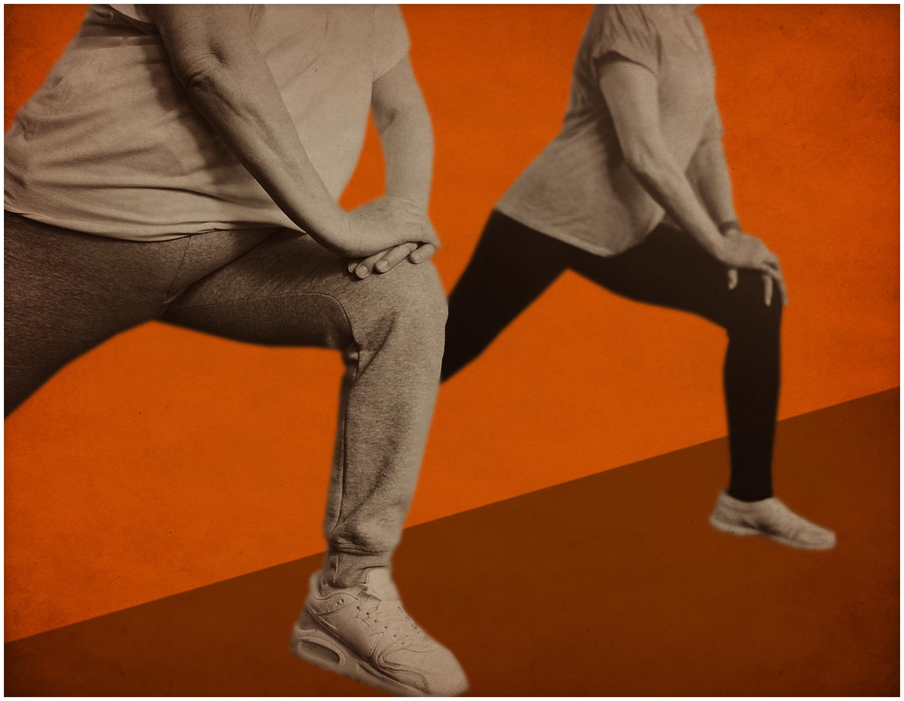
Pulmonary and cardiac rehabilitation classes (exercises and support to help with breathlessness) are available at various centres in Hull and also across the East Riding (ask your GP if a referral would be helpful for you).

Some useful websites for information and support for breathlessness

Asthma and Lung UK
https://www.blf.org.uk/support-for-you/breathlessness

Macmillan Cancer Support
https://www.macmillan.org.uk/information-and-support/coping/side-effects-and-symptoms/breathlessness

Cambridge Breathlessness Intervention Service
https://www.cuh.nhs.uk/breathlessness-intervention-service-bis/resources

British Heart Foundation (BHF)
https://www.bhf.org.uk/informationsupport/heart-matters-magazine/medical/shortness-of-breath

Support for carers

It can be very hard for people living with and caring for someone with breathlessness. Relationships with others can change:

“Gradually we have had less and less to talk about … gives the impression that he has no interest anymore, neither in myself nor in his surroundings… we stopped being good friends like we used to be … The disease has isolated him from the family and myself, and now we have restricted issues to talk about … it makes me sad when I think about it.”
Often carers need to take on new roles:
“It's a hard time I tell you and it gets you down. When you think what the nurses do in hospital, giving him his tablets and everything. I'm doing a thousand jobs as well. I'm just going crazy because you don't get to the end of it... We're nurses, we're doctors, we're housewives, we're cooks, we're gardeners.”
“Over the last 8–9 years, I feel inside that my role’s completely changed. Somewhere in all of this, I’ve lost who I am. I’m more like his nurse or ‘I need you’ kind of thing. That’s it – I need you, and I don’t know how to explain it. I just feel like somewhere me, myself, I’m lost. I don’t know who I am any more. I don’t know if anybody can understand that.”
And sometimes people can become isolated:
“We often feel lonely and on the edge of things.”

Uncertainty about the future can make people feel distressed and unfortunately, these difficulties may not be understood well by others and people don’t always get the help they need:

“The emotional thing is extremely, extremely important. You don’t get the understanding ... you can just like get caught up in a downward spiral and you end up in this little place all by yourself ...”

It is very important that people caring for breathless patients take time to look after themselves well and seek support from both friends and family and also from professionals when needed.

Useful information booklets on caring for people
https://www.chcpcic.org.uk/uploads/optimadmin/document/document/443/EI9035-Looking-after-someone-Eng-2017.pdf

or
https://www.england.nhs.uk/publication/a-practical-guide-to-healthy-caring/

Carers UK
www.carersuk.org

For more information on breathlessness and to download copies of this booklet visit the Bringing breathlessness into View website:

https://www.hyms.ac.uk/bringing-breathlessness-into-view

